PRIVATE DOCKER REGISTRY
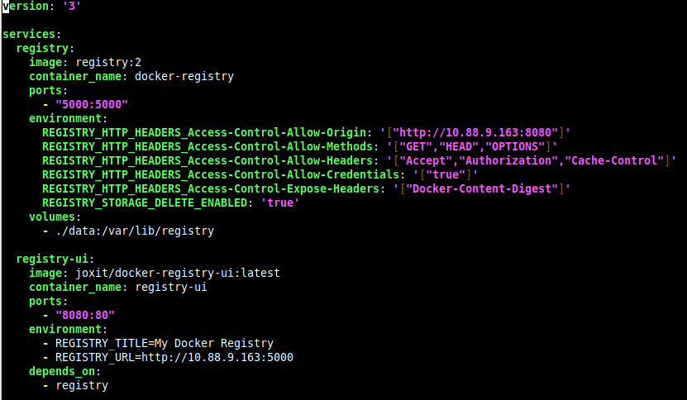
- docker-compose.yml

- Docker compose up -d
- http://IP_LOKAL:port
- /var/snap/docker/current/config/daemon.json

- Tambahkan di
- Docker pull nginx
- docker tag nginx localhost:5000/nginx-custom
- docker push localhost:5000/nginx-custom
- Lihat di UI, apakah ada image nginx

Basic Authentication For Private Registry
- Buat folder auth/htpasswd
- htpasswd -Bc htpasswd (nama user)
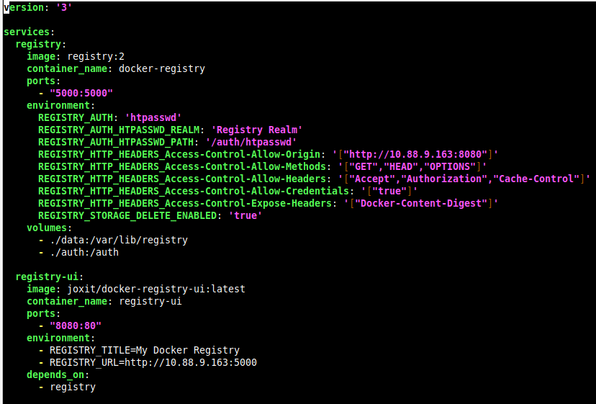
- version: '3'

